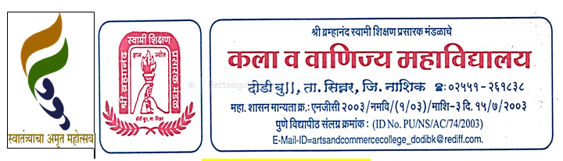

**Room No. 101 IQAC**

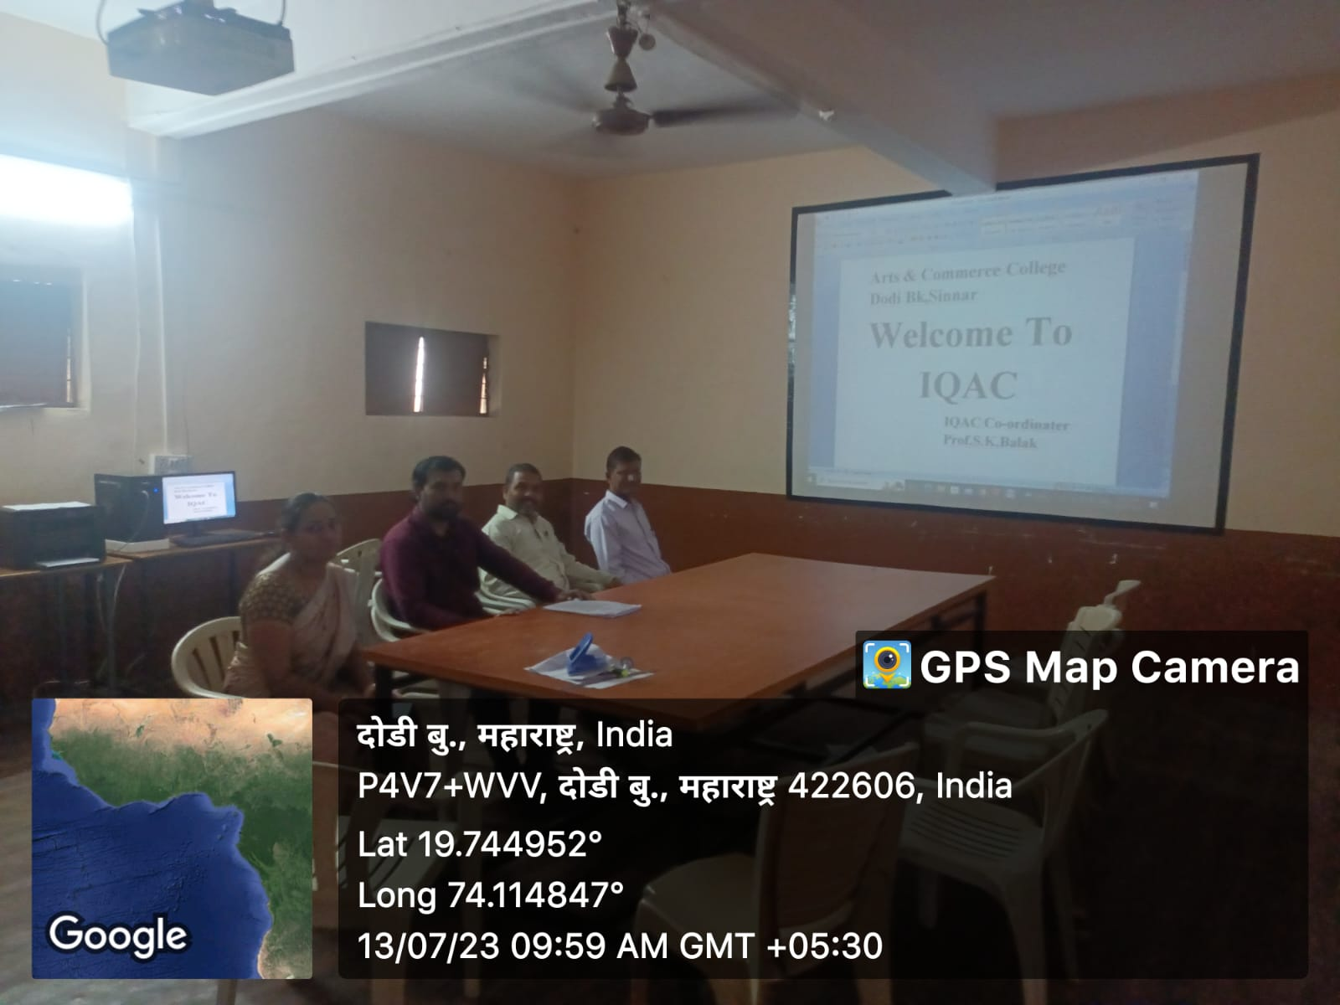

**Room No.102 – English/ Political Science Department** 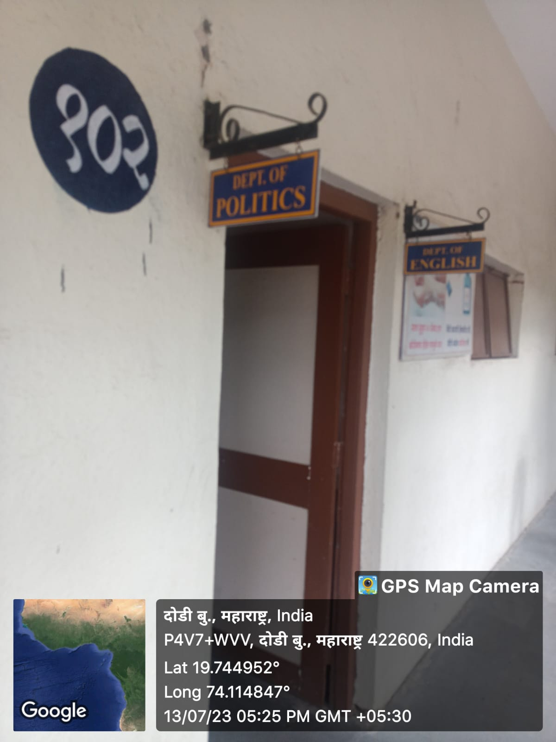

**Room No.103 History / Economics Department**

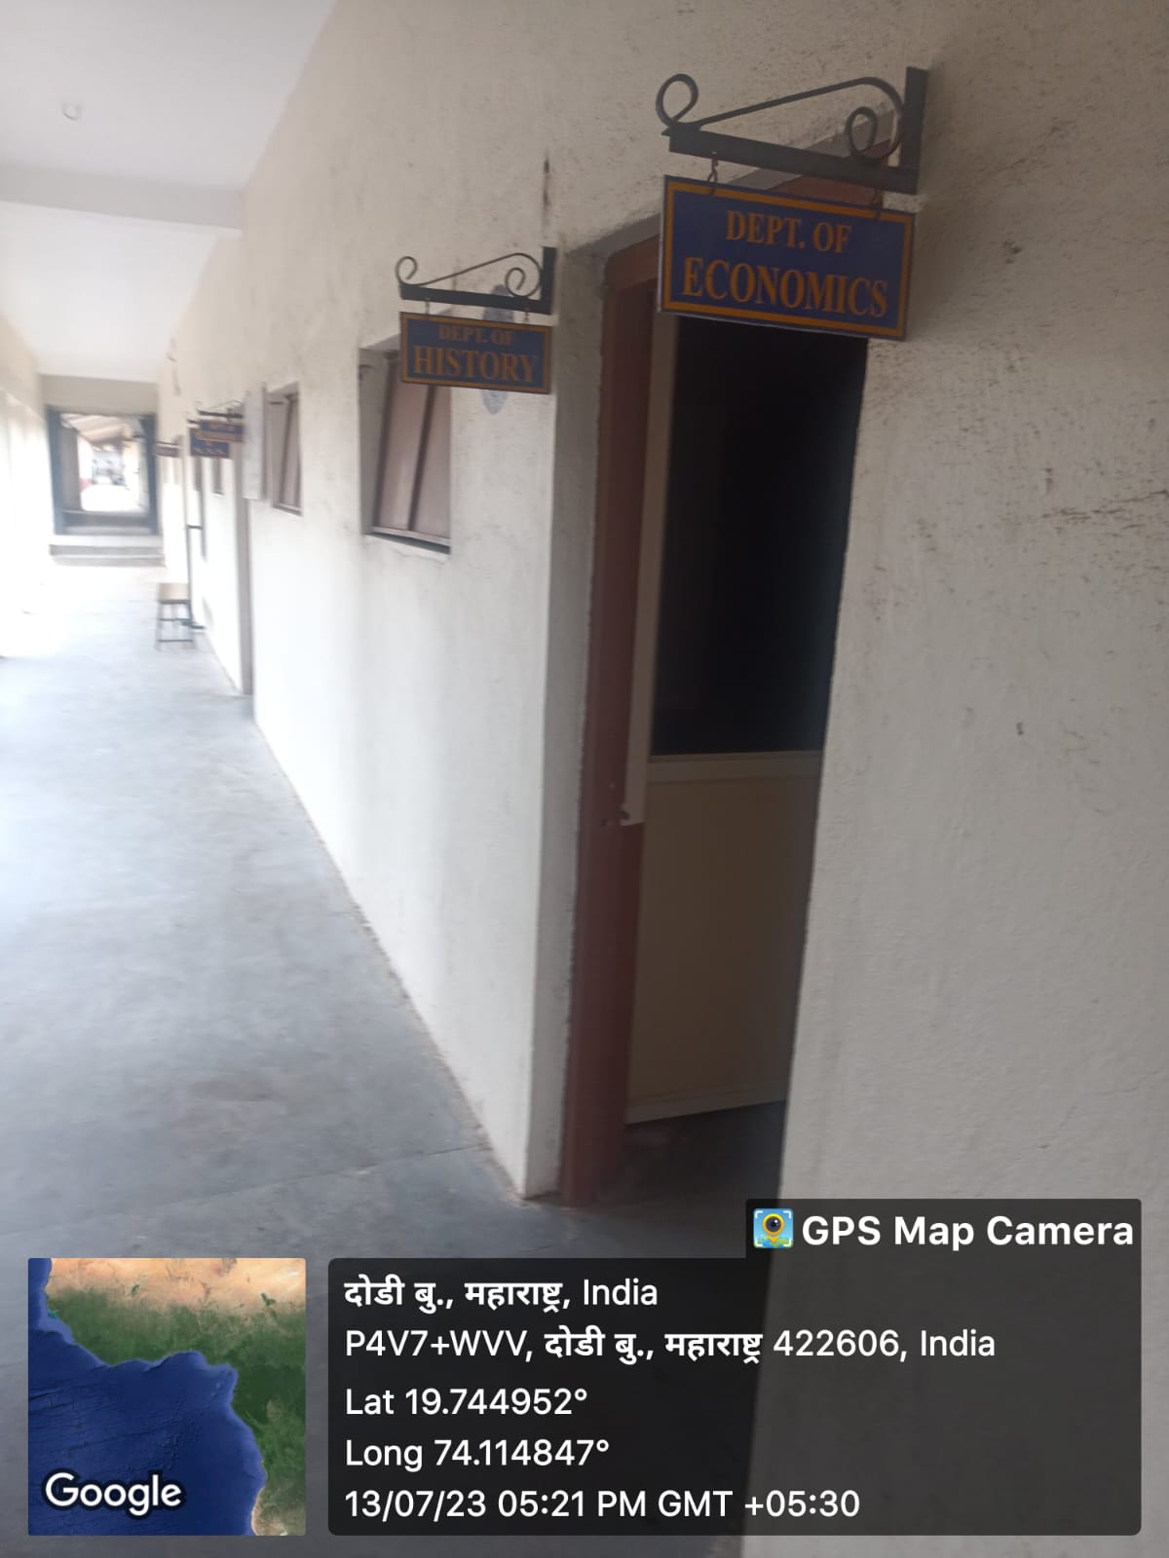

**Room No. 104 Ladies Common Room**

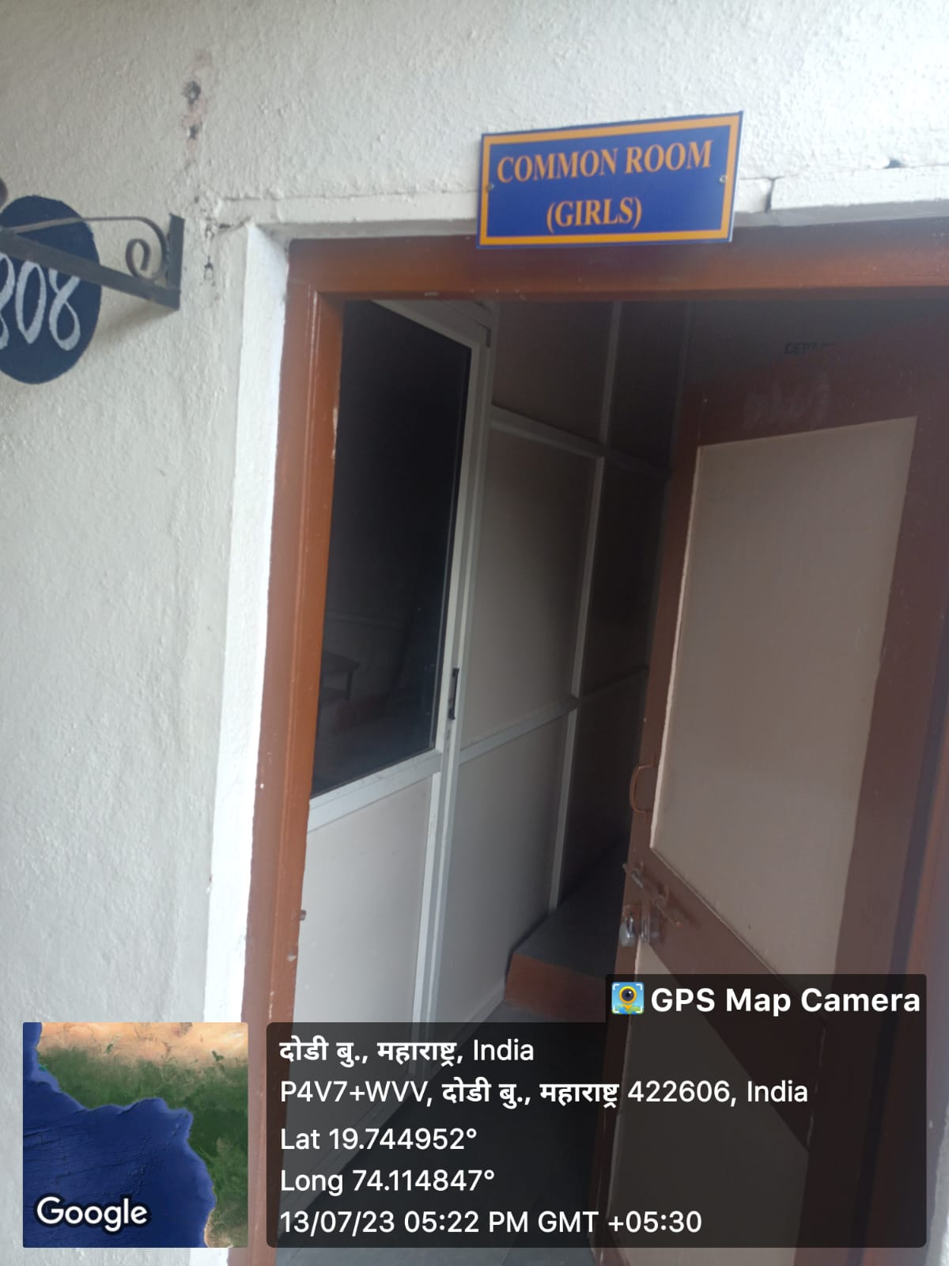

**Room No 105 Principal Cabin**

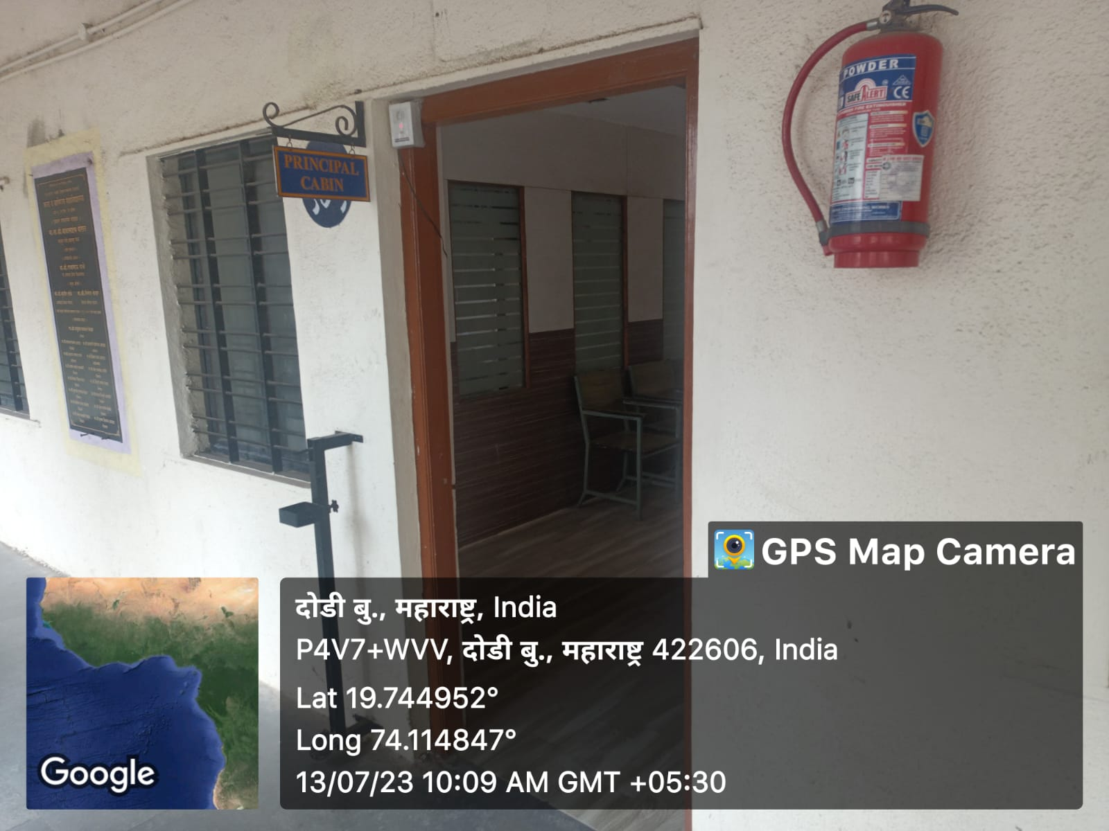

**Room No. 106 Office**

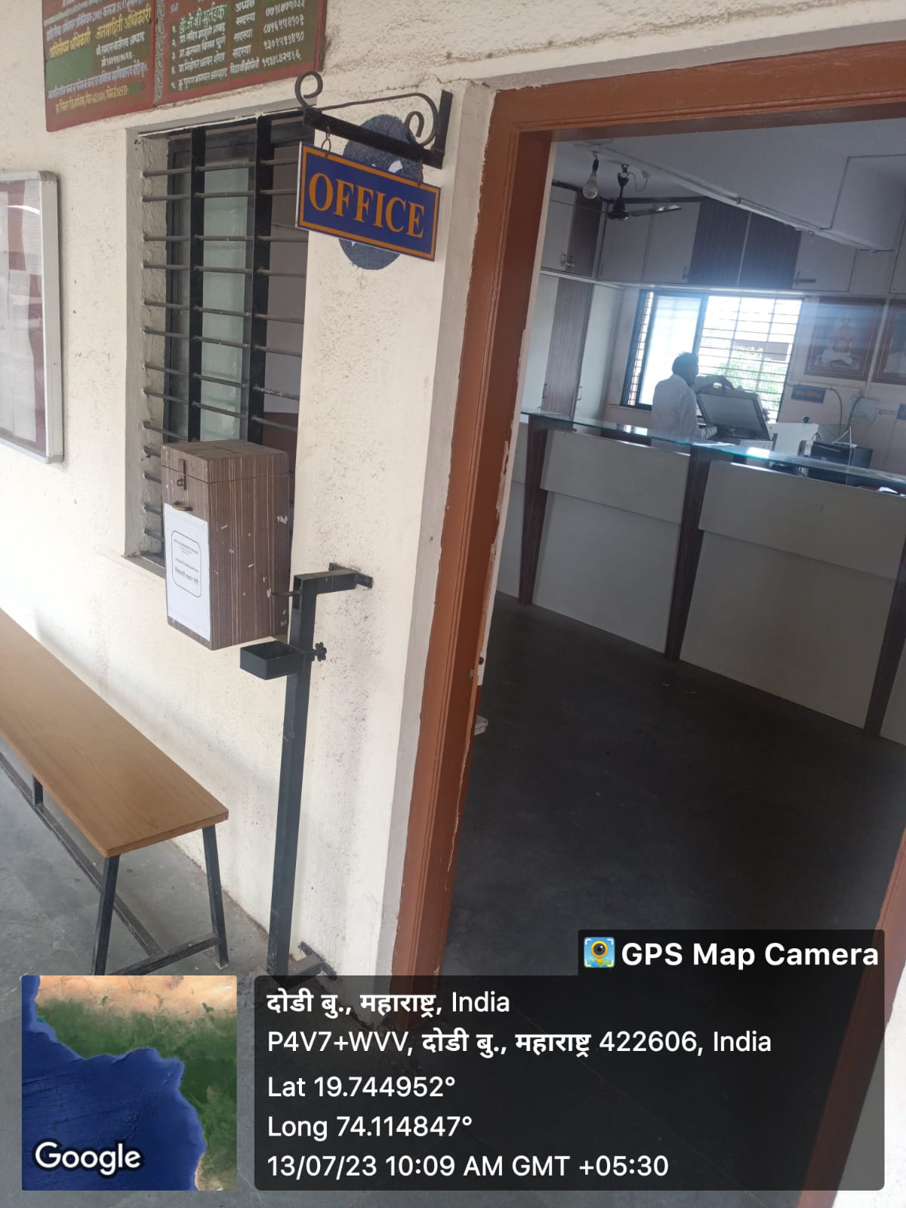

**Room No.107 Exam Department**

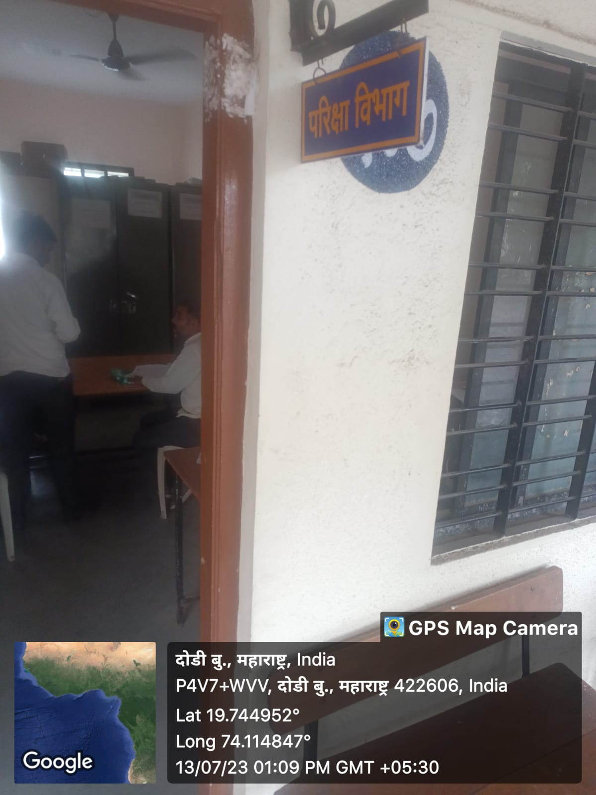

**Room No.108 Language Lab**

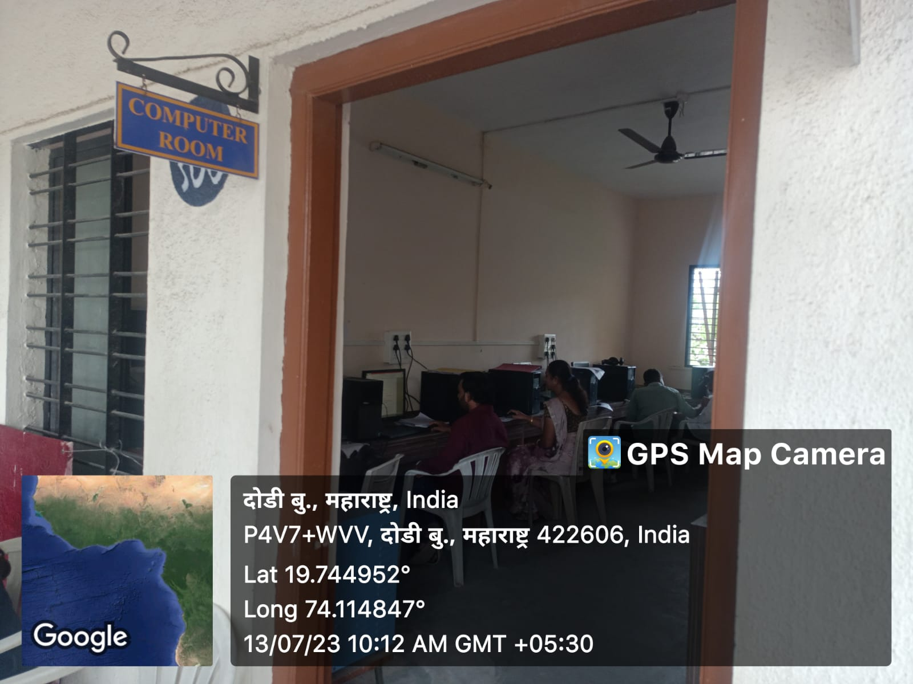**Room No.109 Staff Room / Student common Room**

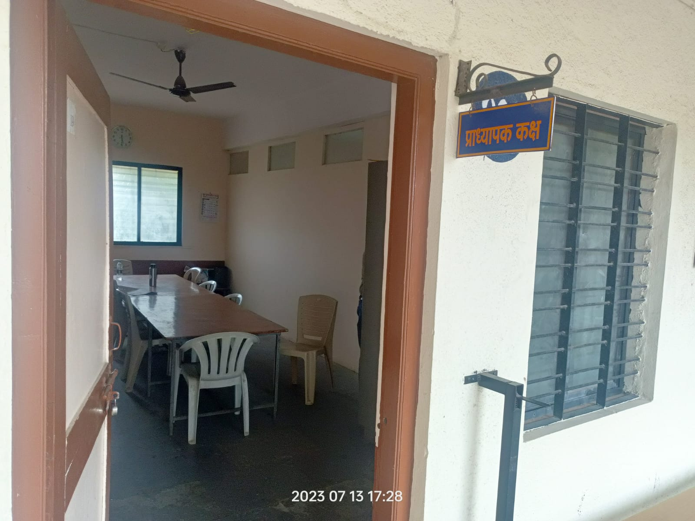

**Room No . 110 Library information science Department**

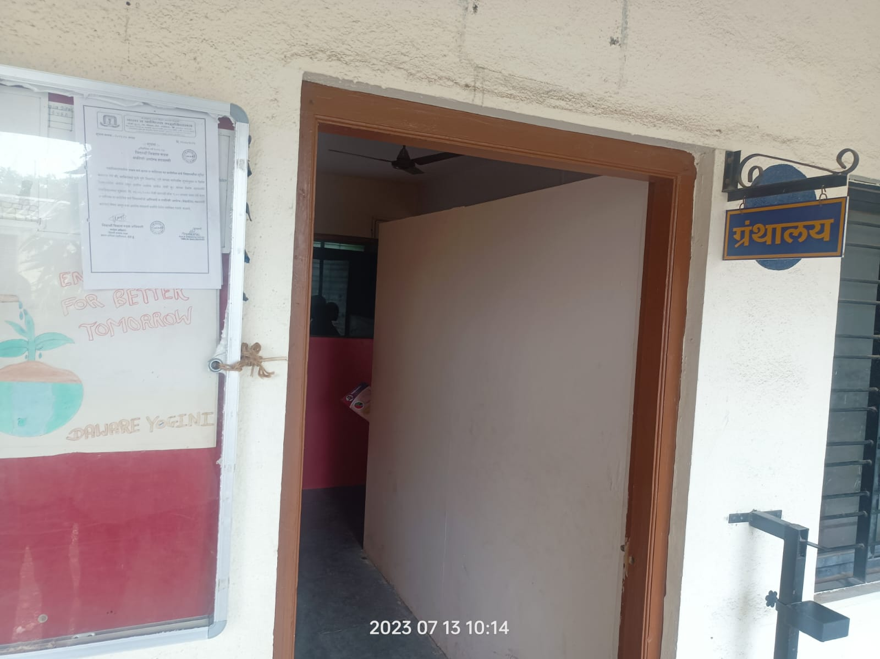

**Room No. 111 Marathi/Geography Department**

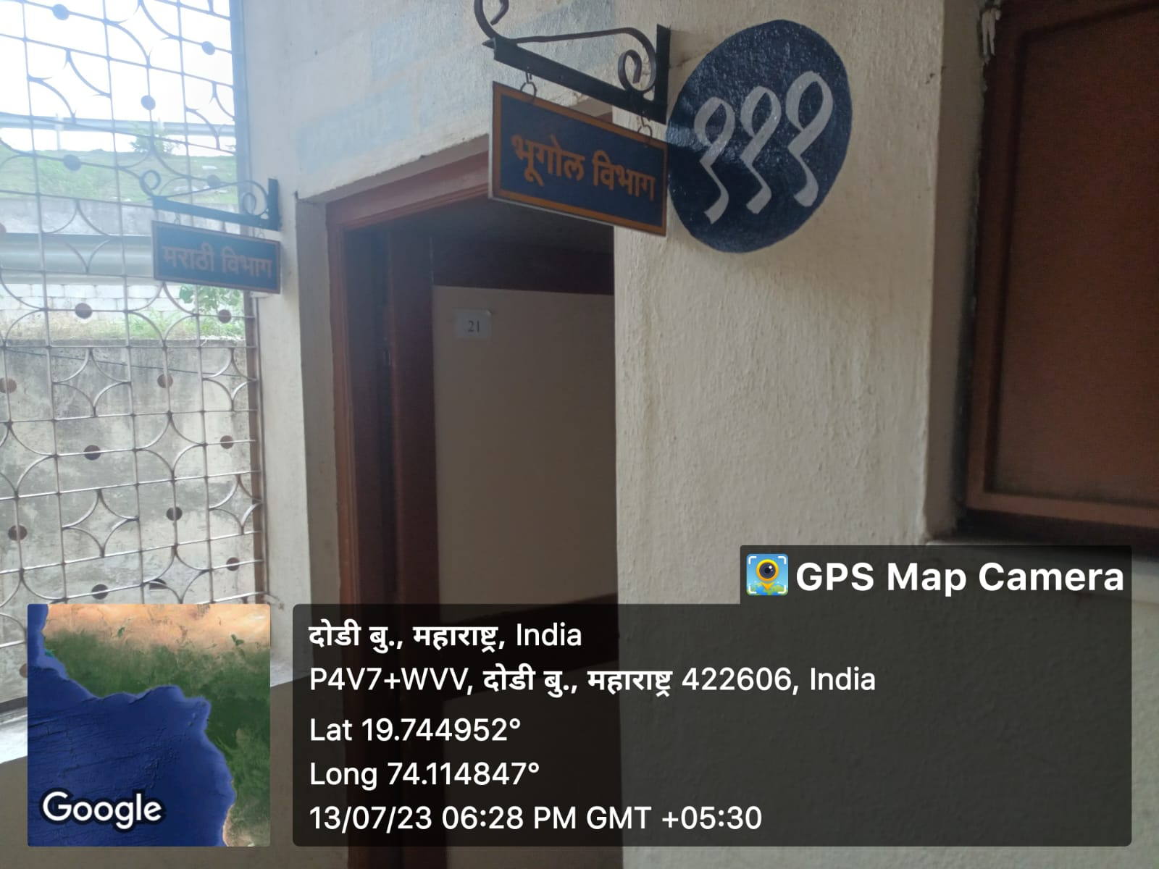

**Room No . 112 I.T.C Room**

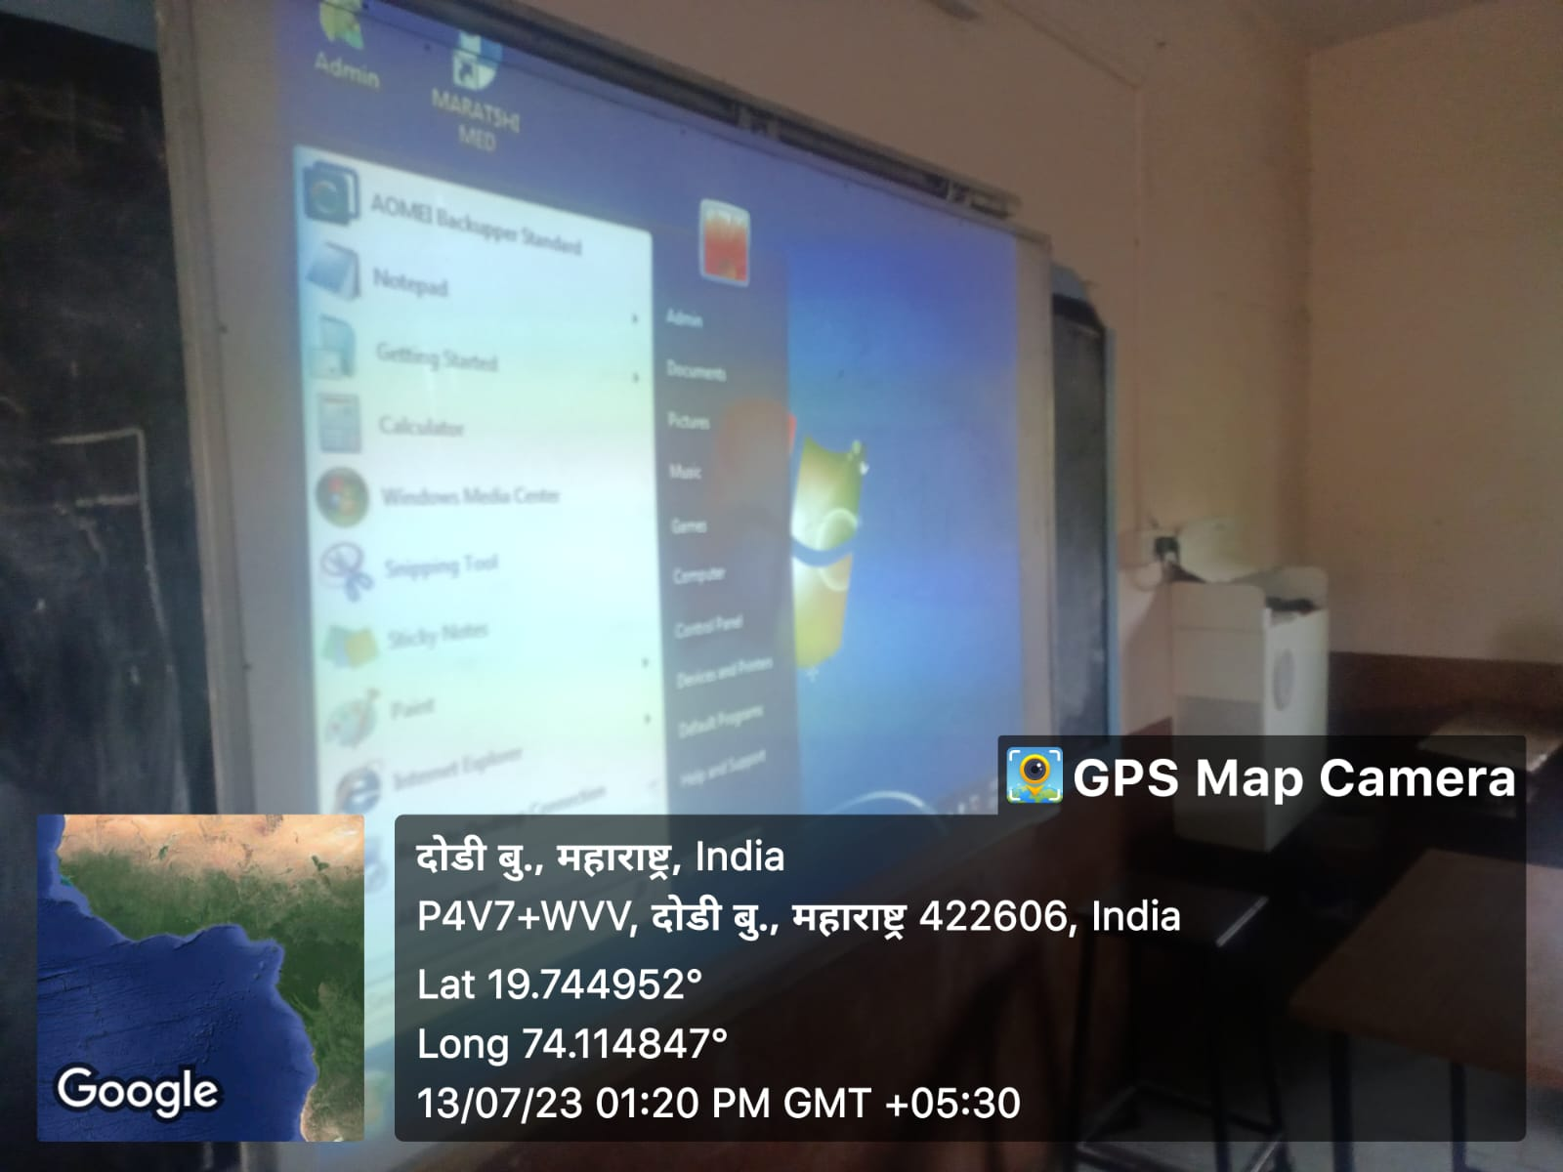

**Room No.113 I.C.T Room**

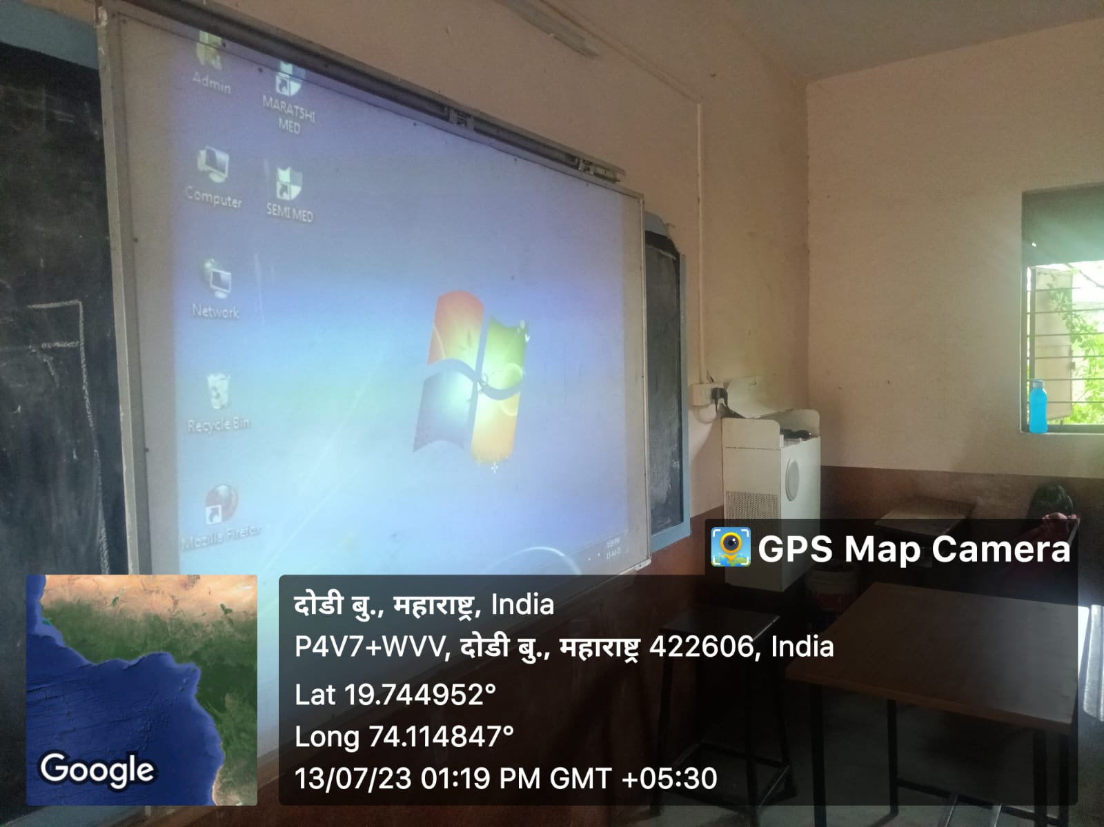

**Room No.114 .Management hall**

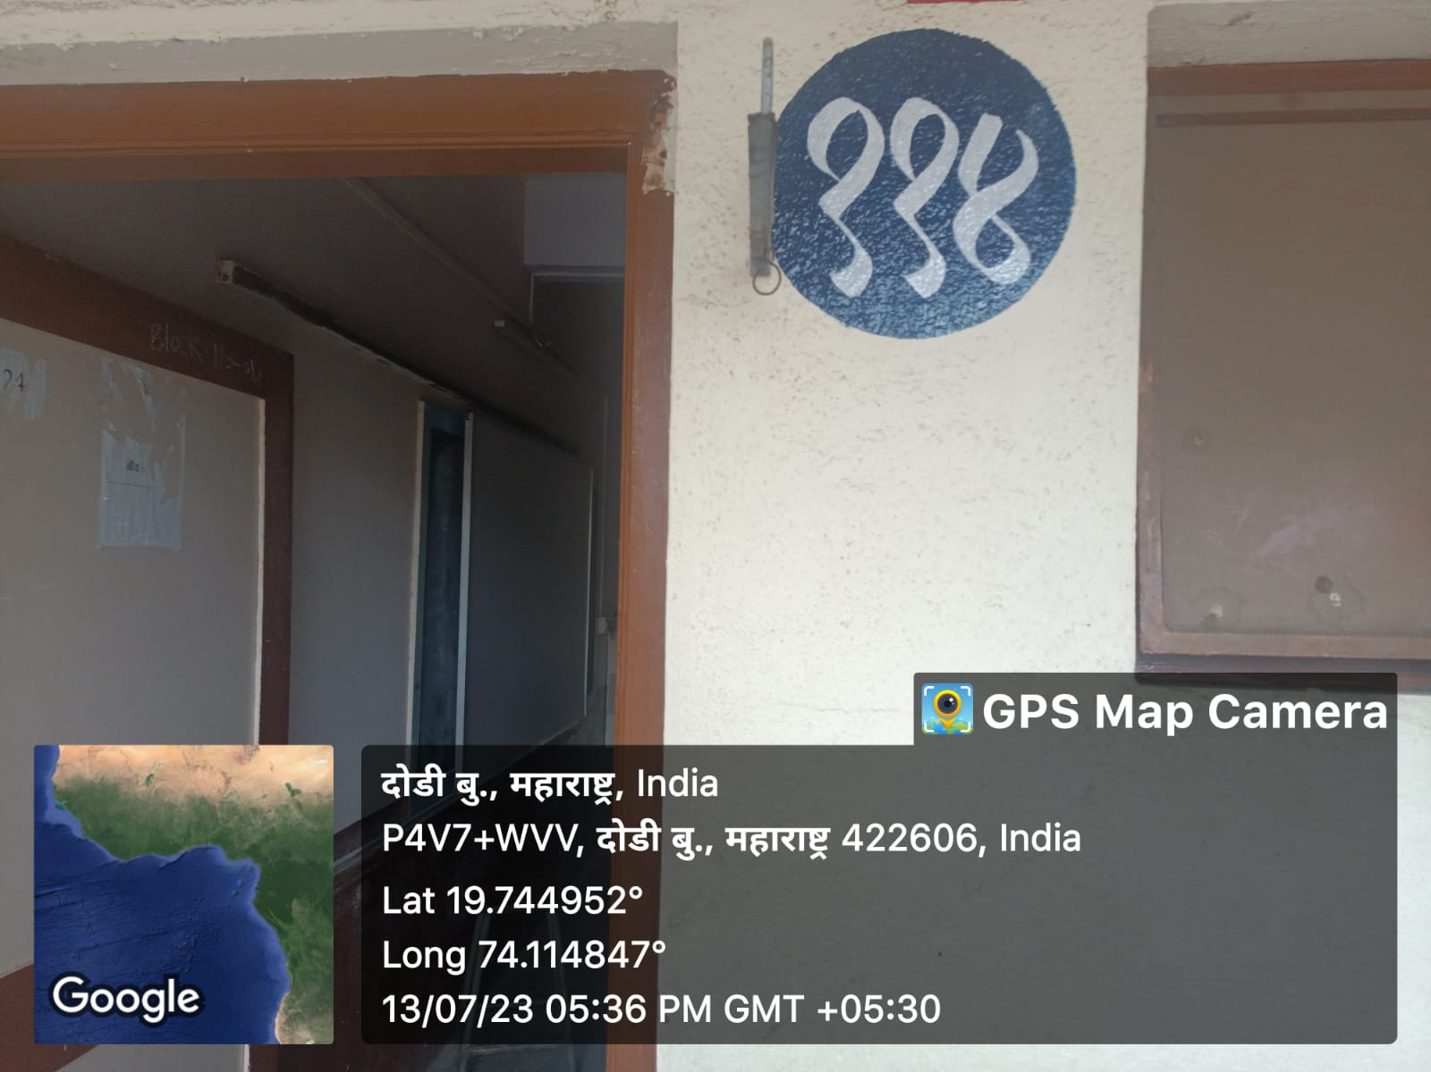

**Room No.115 Store Room**

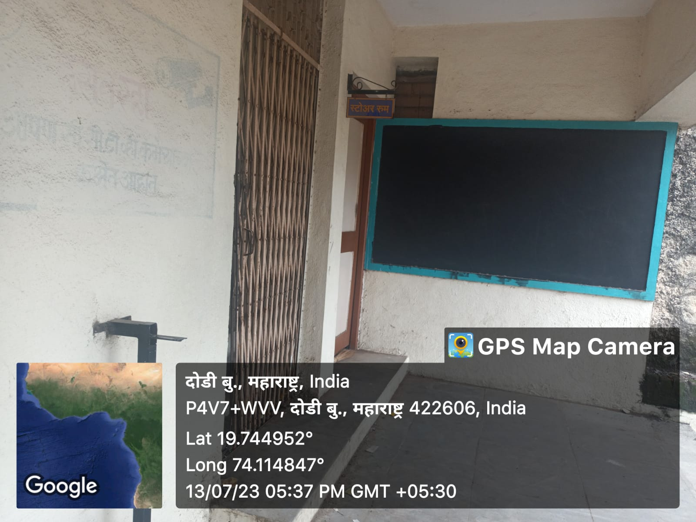

**Room No .116 Commerce Department**

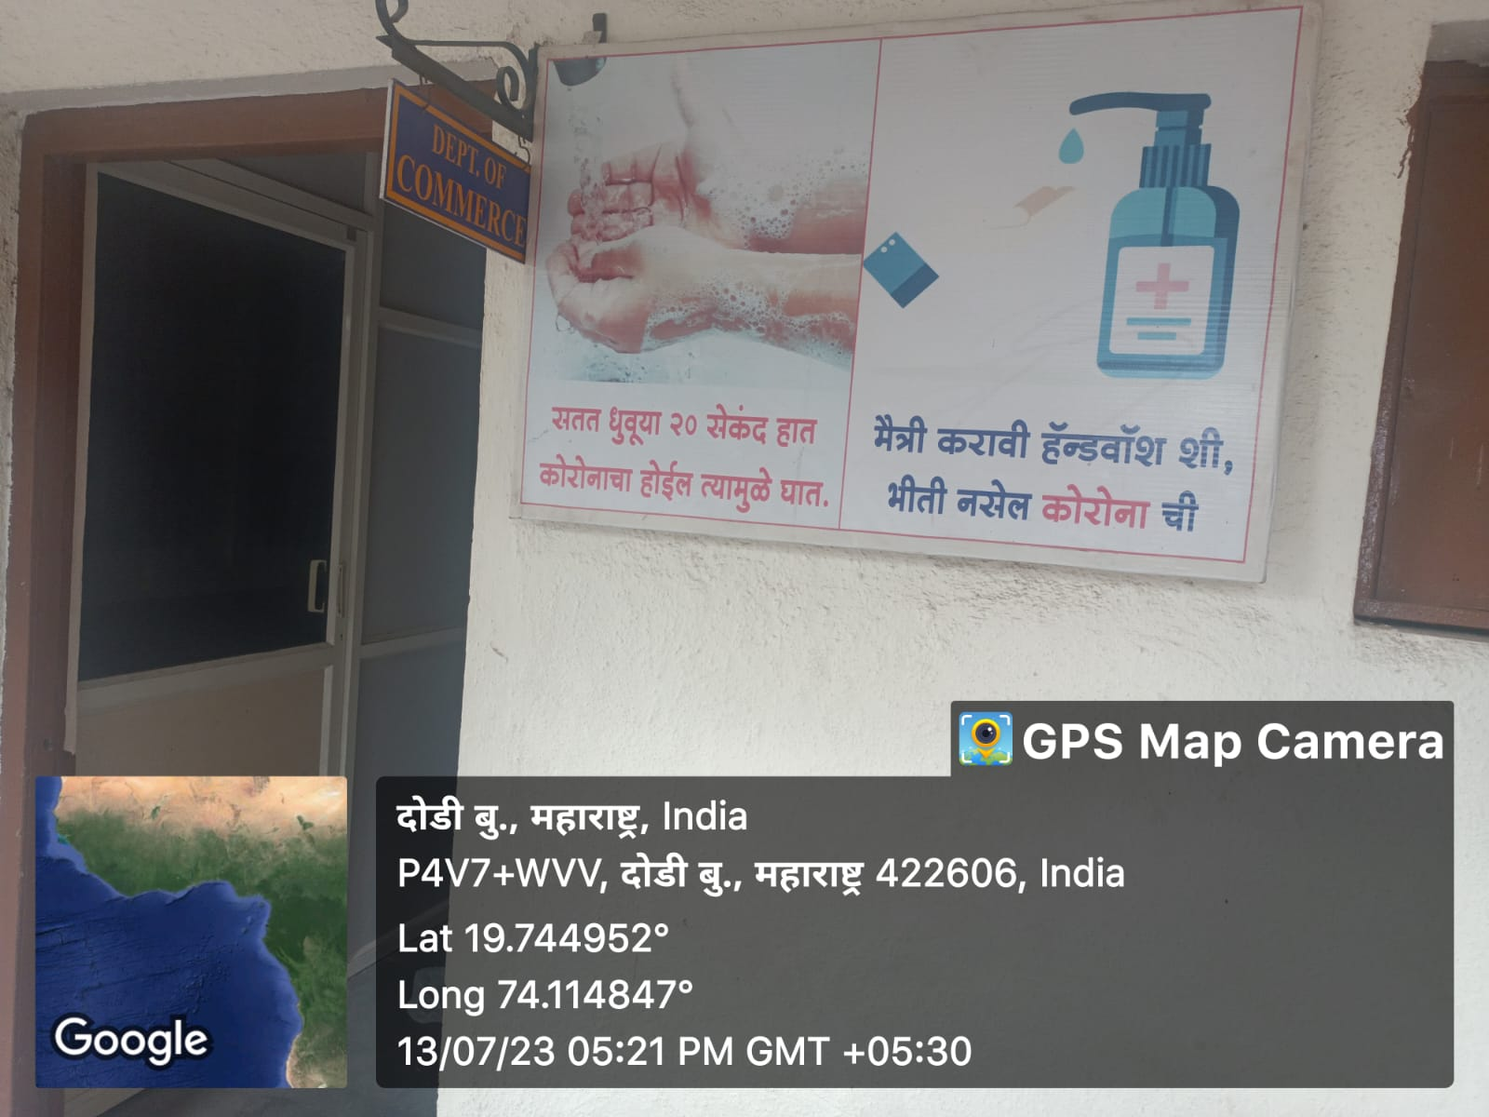

**Room No.202 competitive Exam Centre**

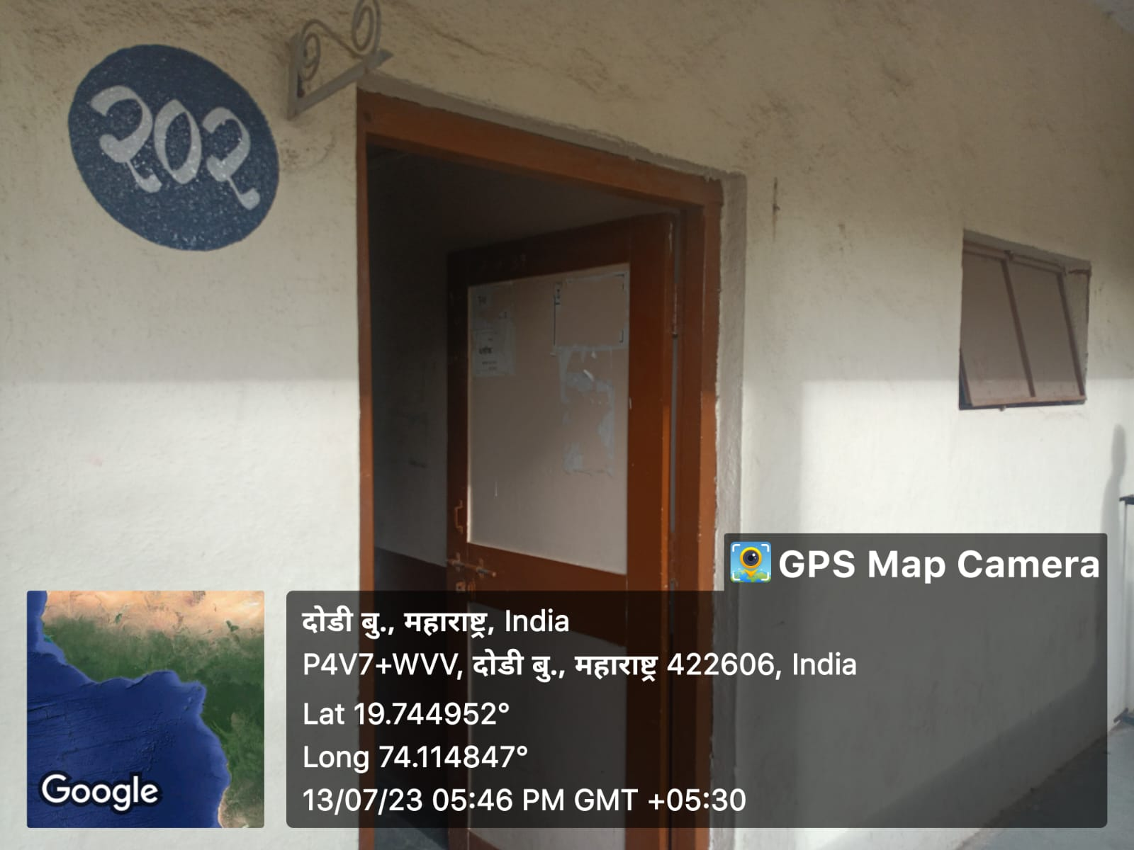

**Room No.203 Yoga Room**

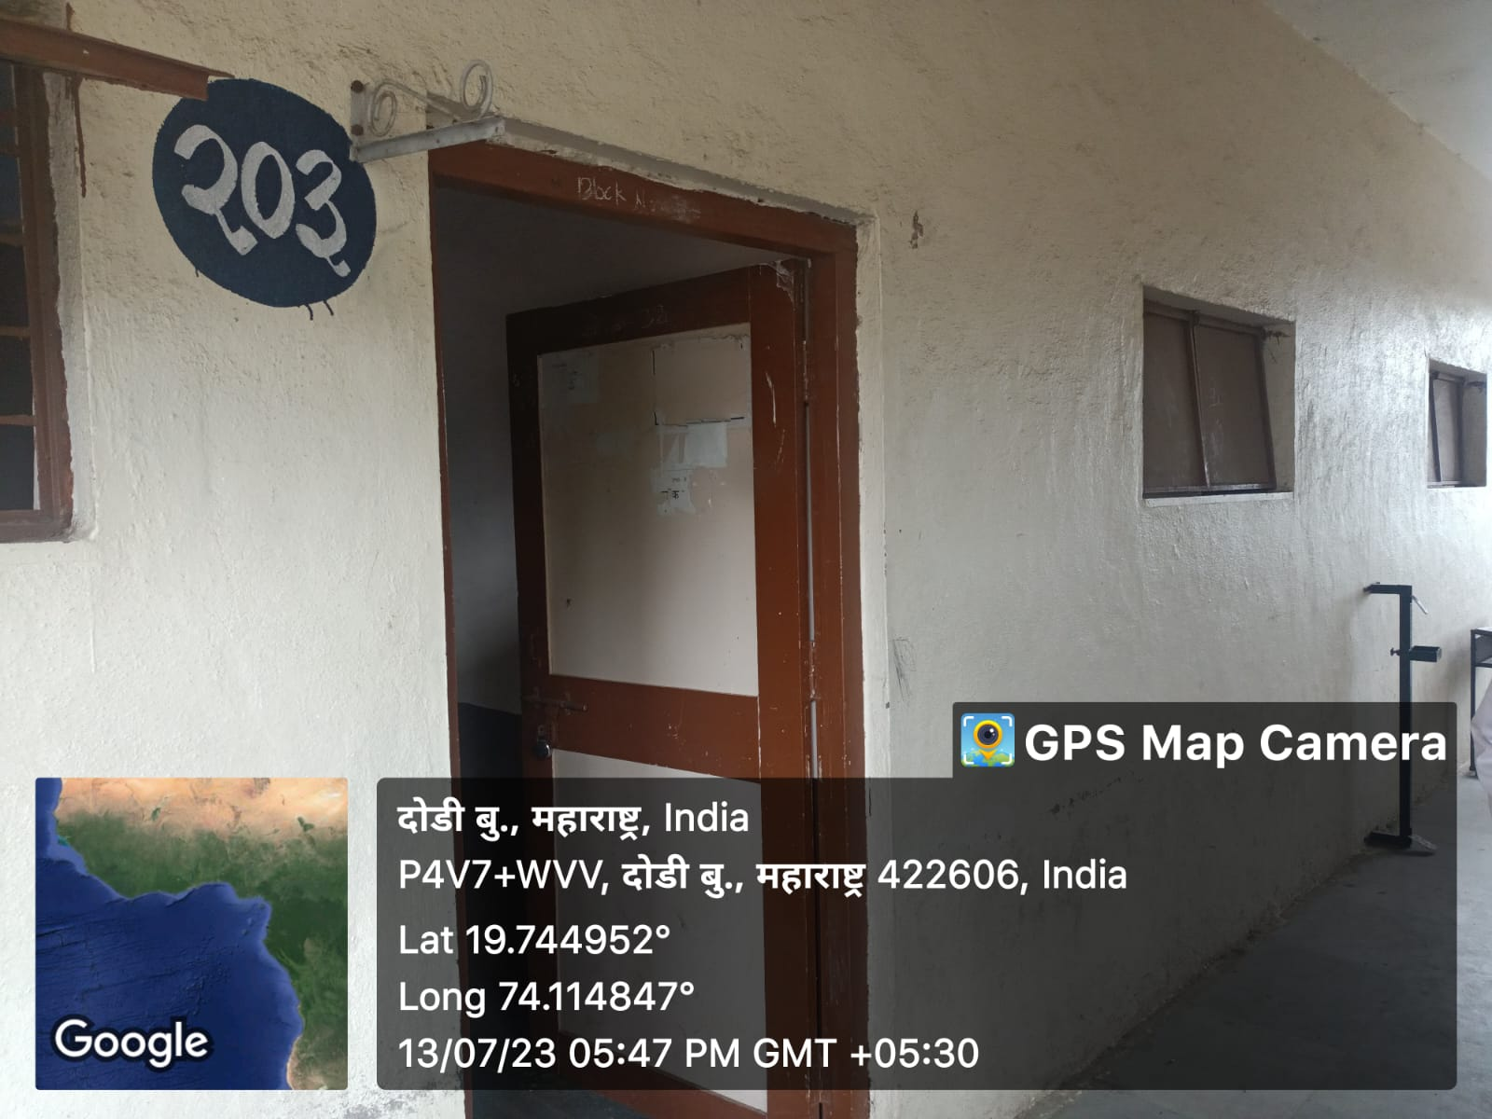 **Room No.204 S.O.W/N.S.S Room**

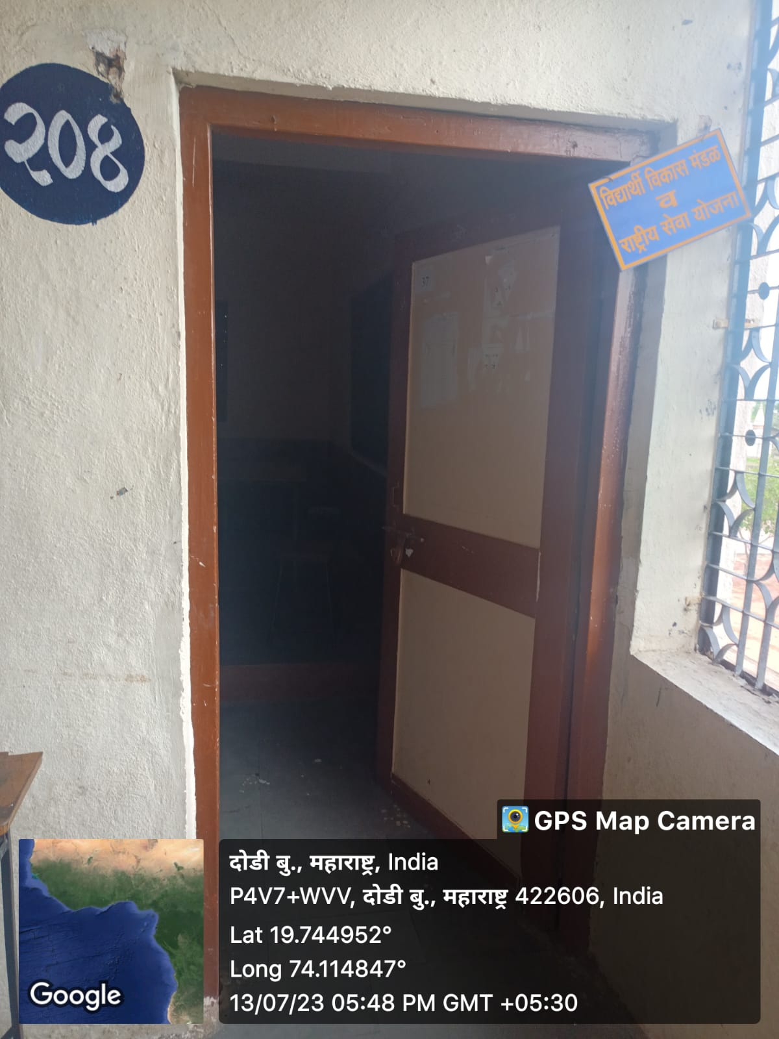

**Room No.205 politics lecture hall**

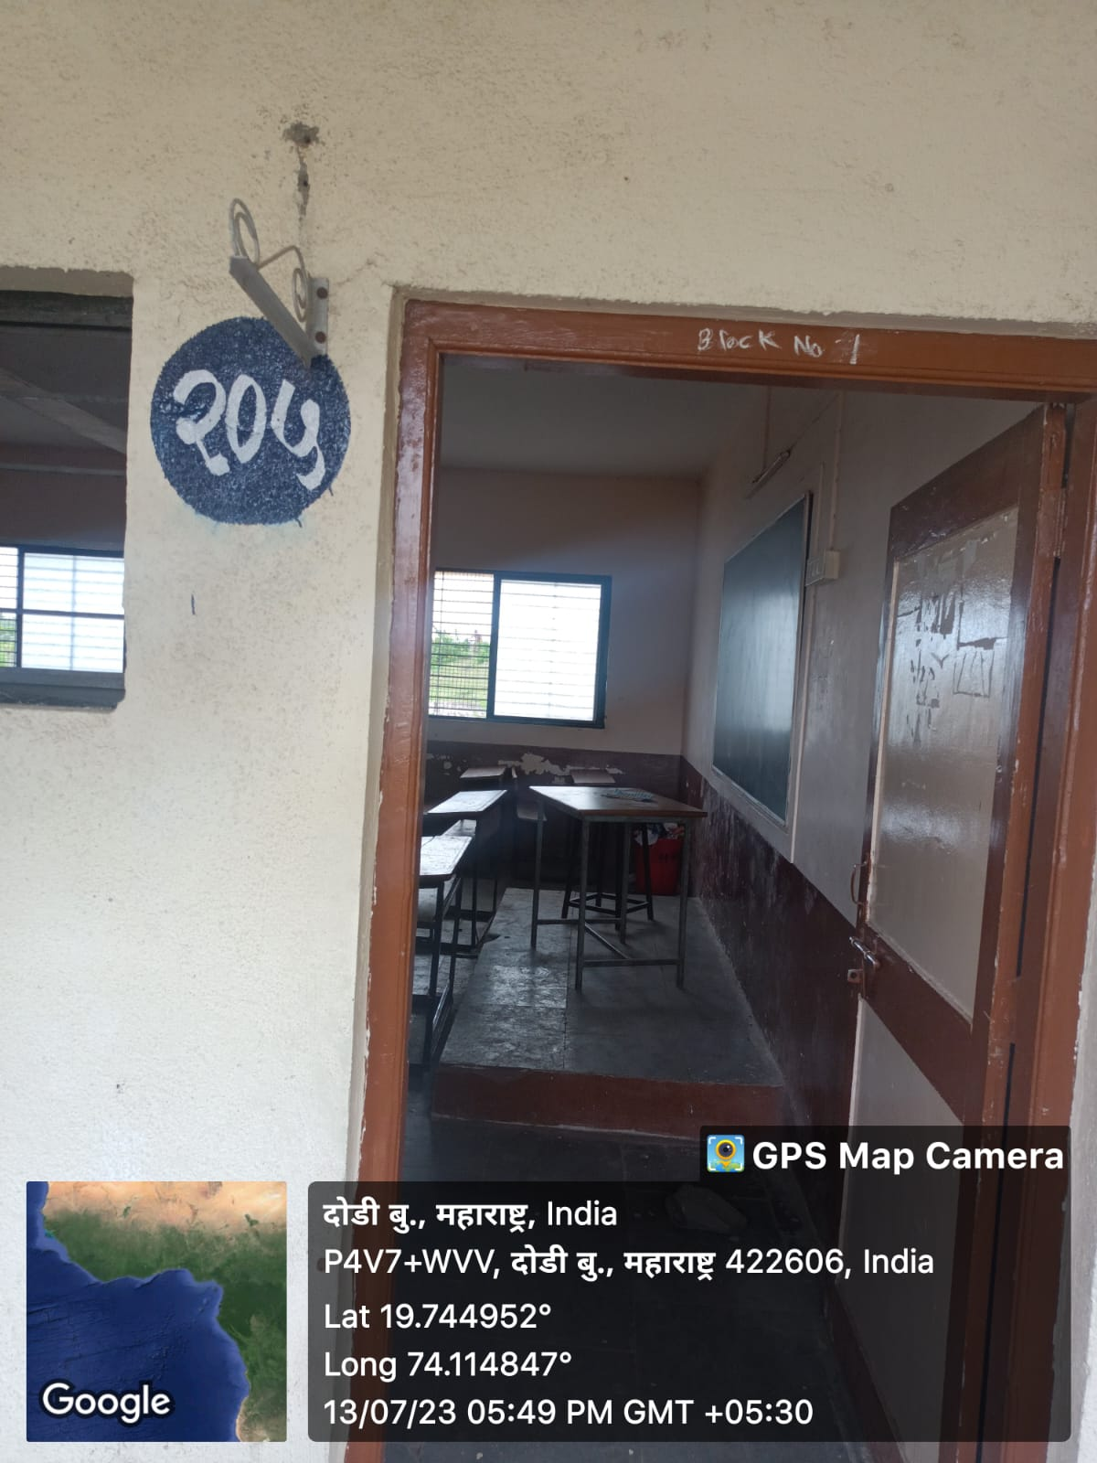**Room No. 206 History Lecture Hall**

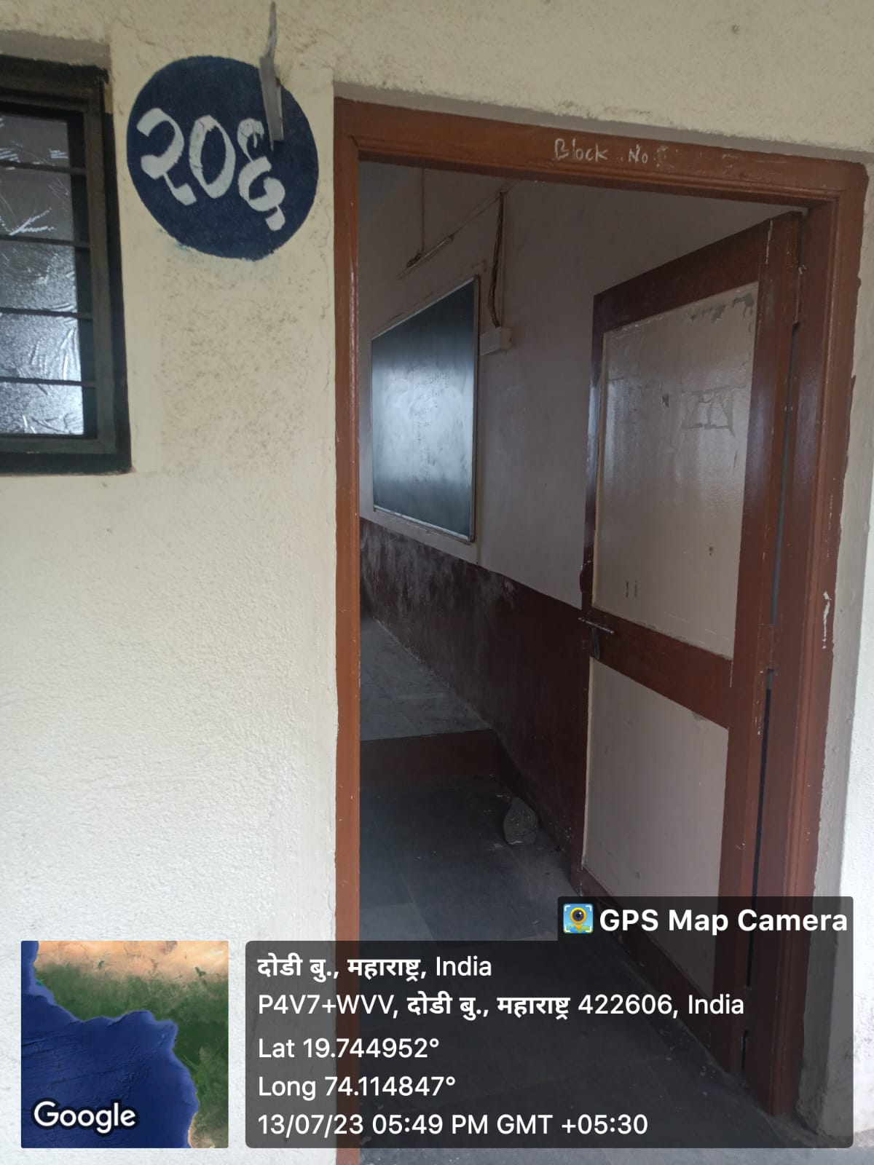

**Room No.207 Economics Lecture Hall**

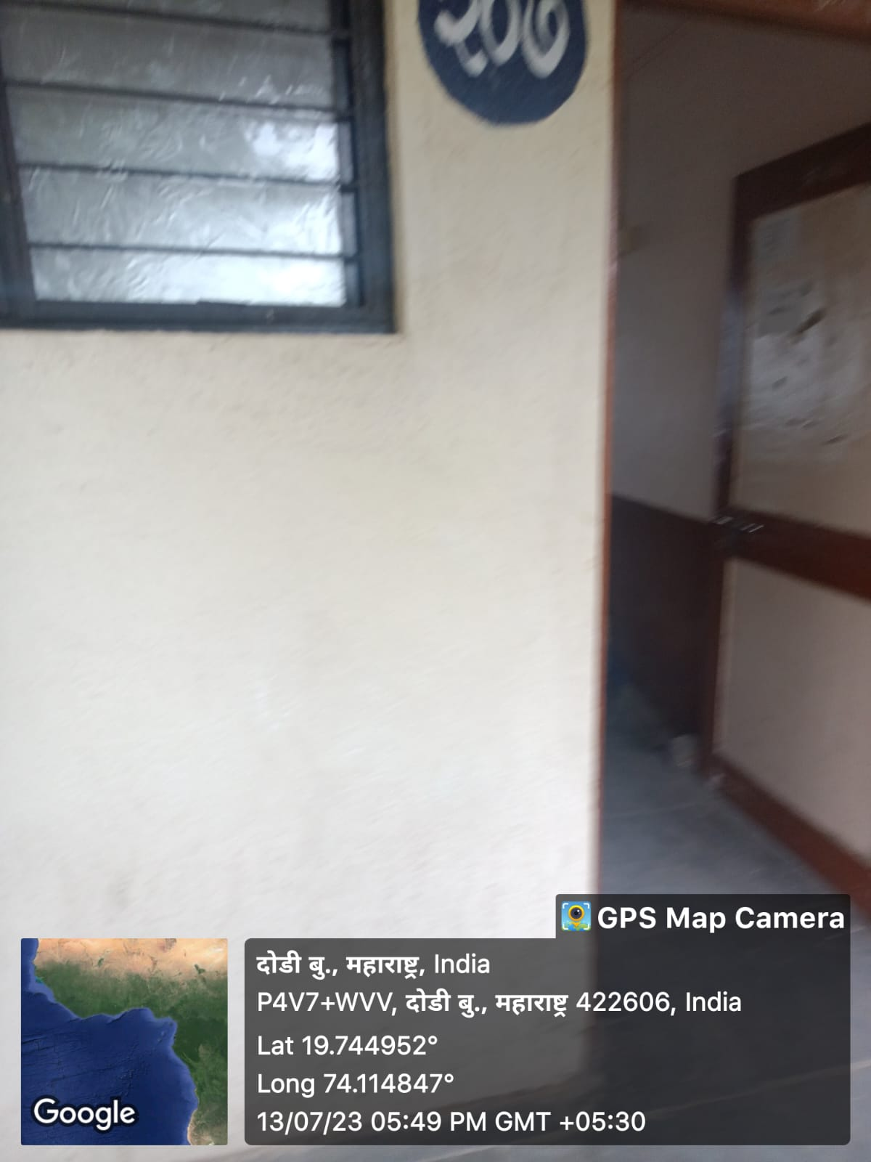

**Room No.208 Geography Lecture Hall**

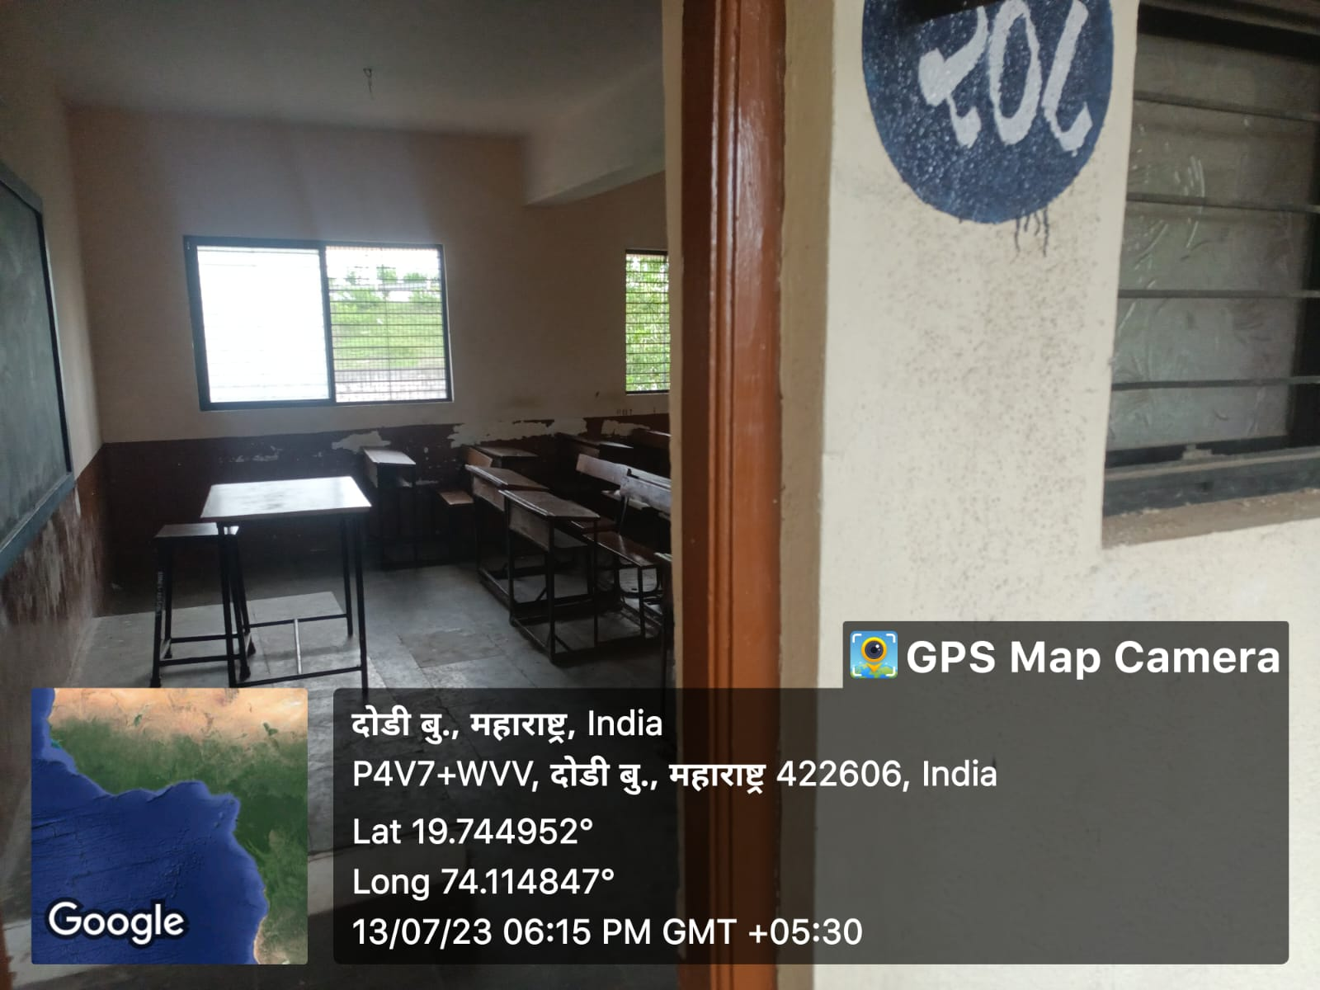

**Room No.209 Marathi Lecture Hall**

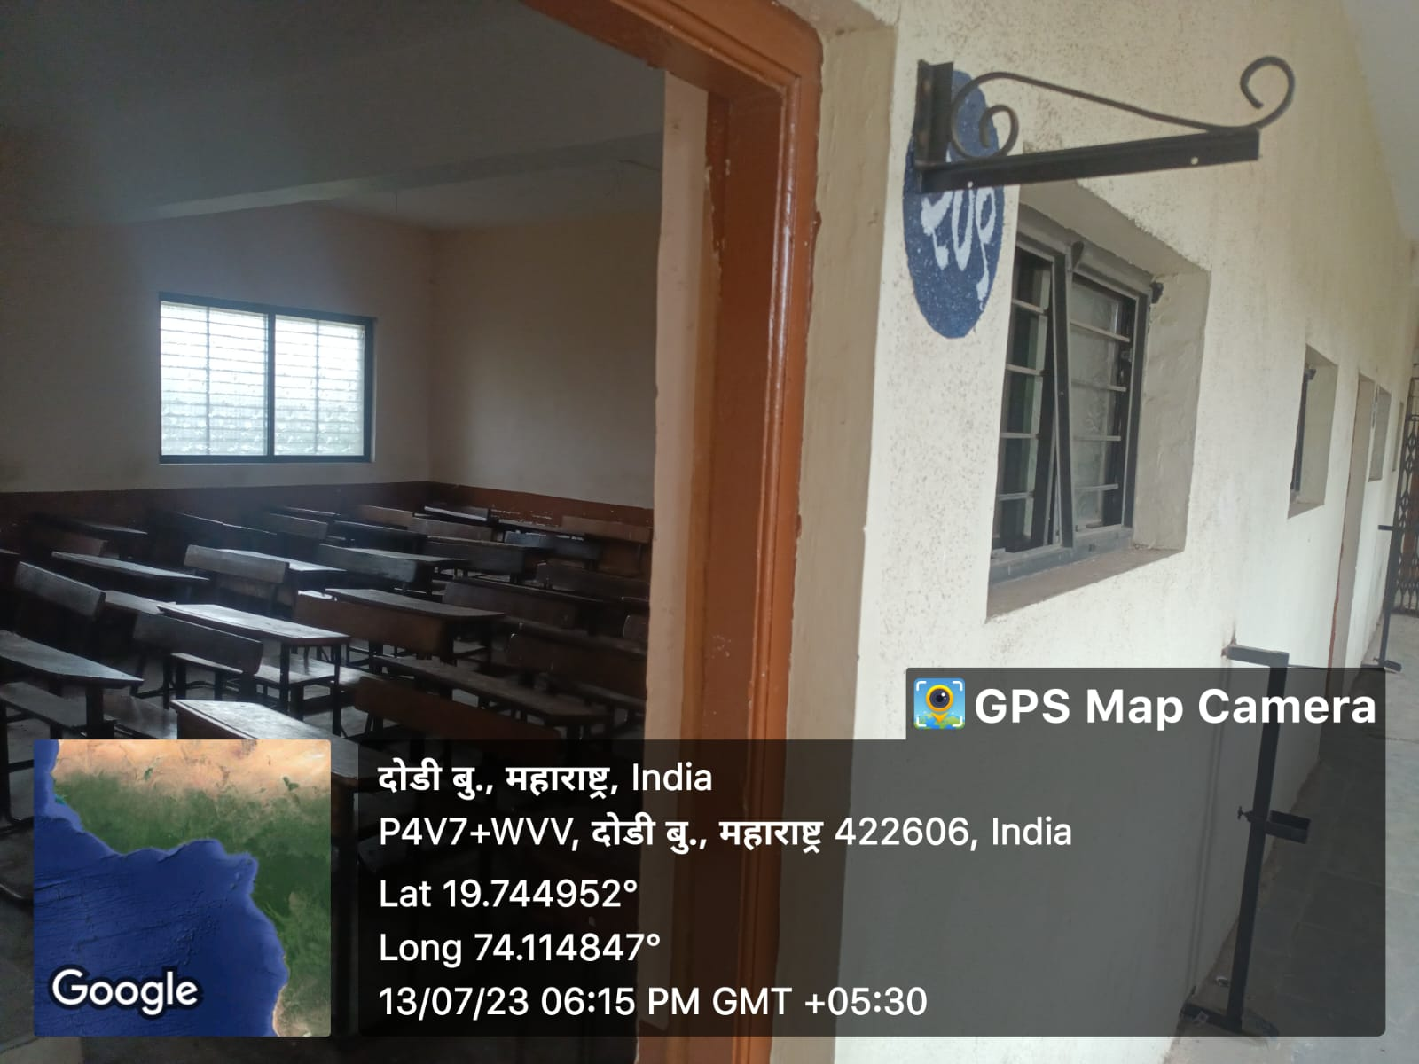

**Room No.210 English Lecture Hall**

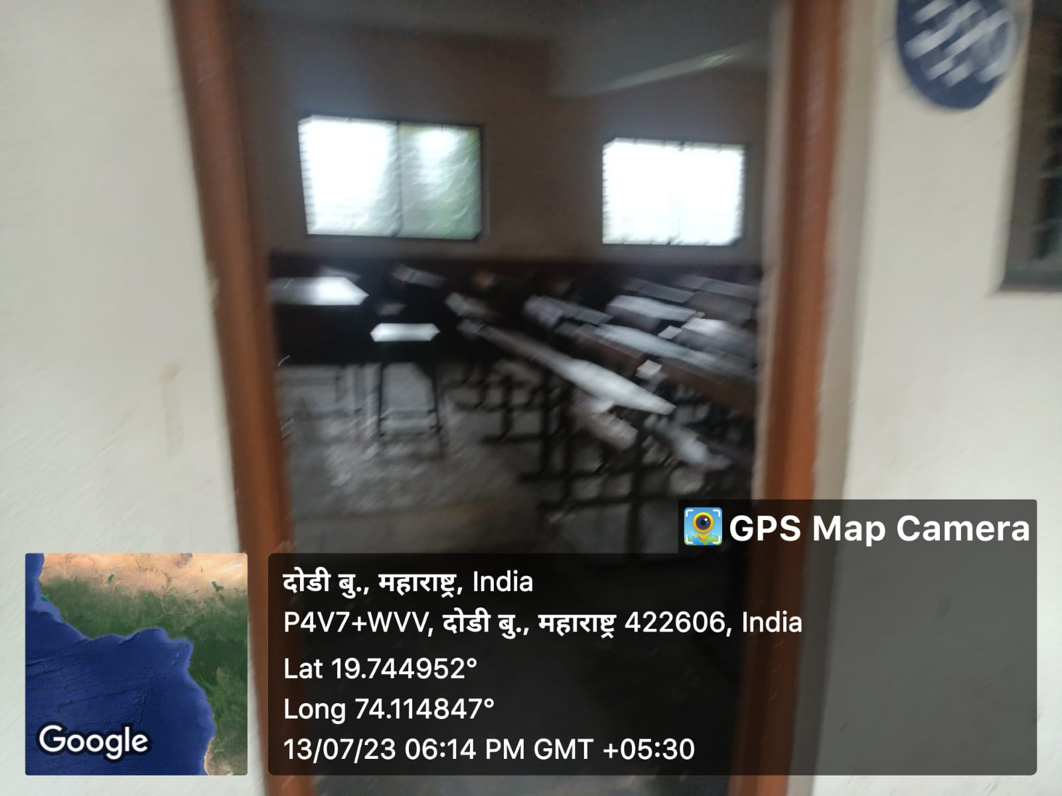

**Room No.211 Store Room**

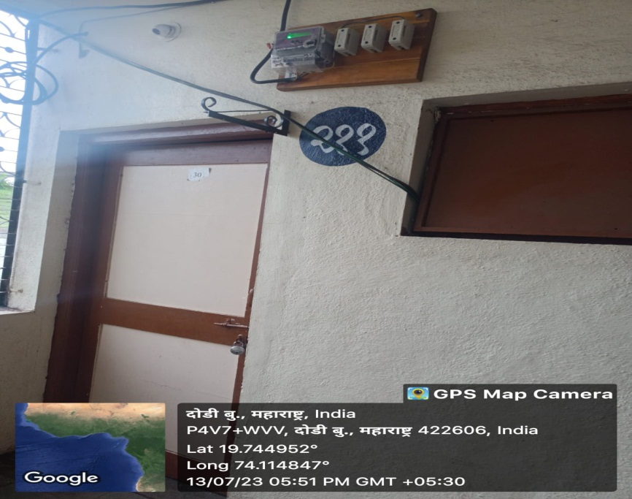

**Room No.212 TYBA Class Room**

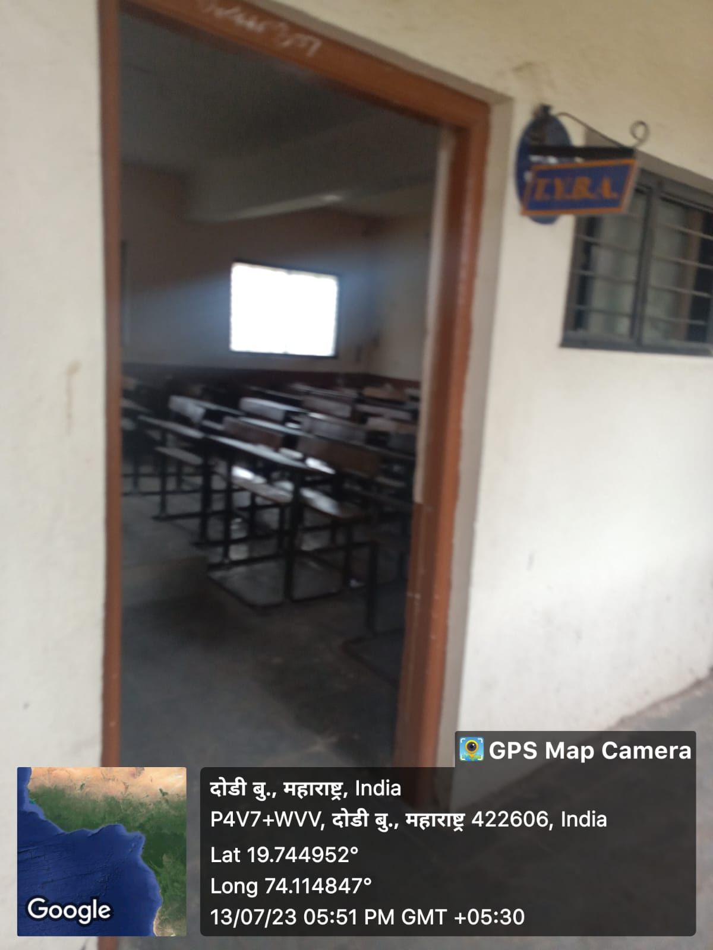

**Room No.213. SYBA Class Room**

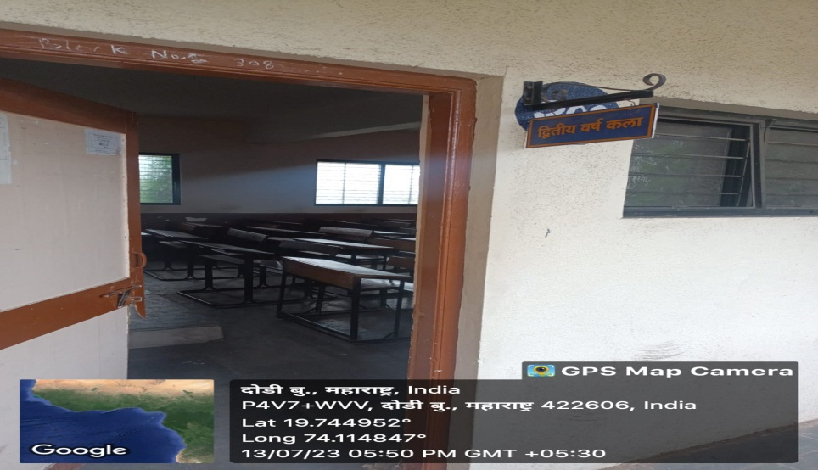

**Room No.214 FYBA Class Room**

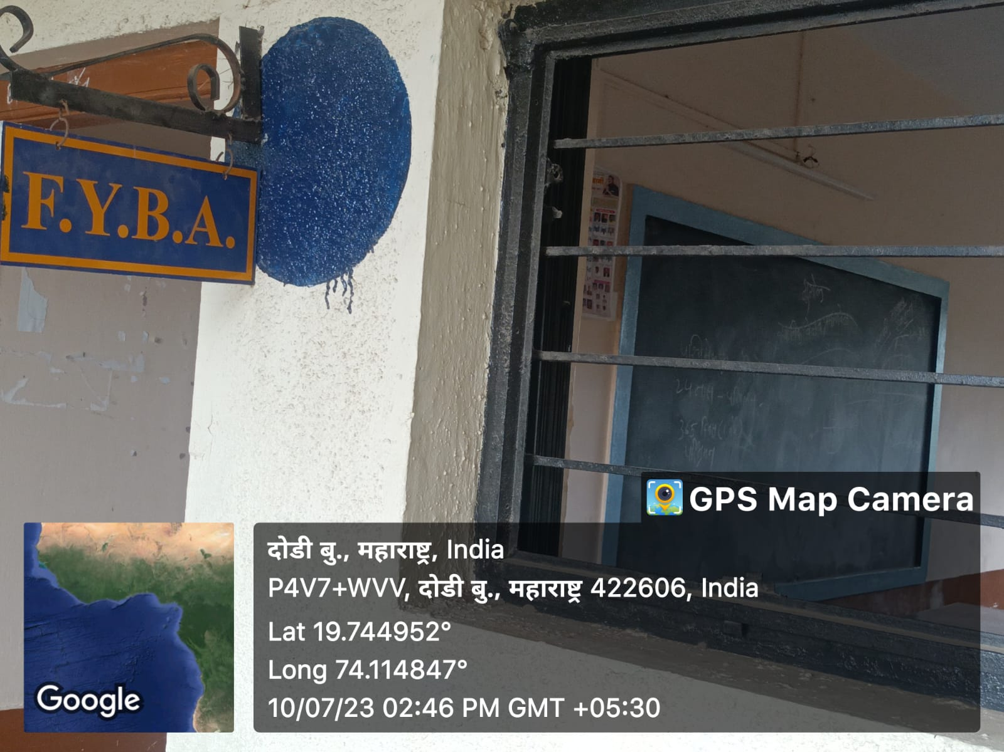

**Room No.301 TYBCOM Class Room**

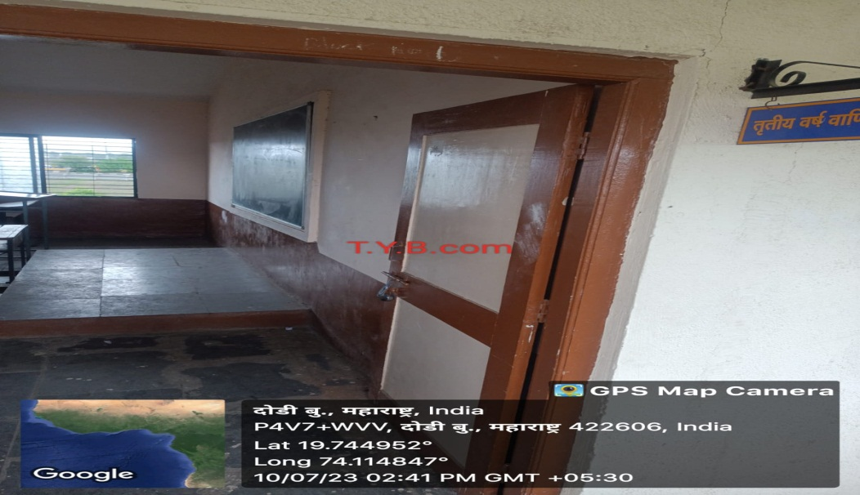

**Room No.302 SYBCOM Class Room**

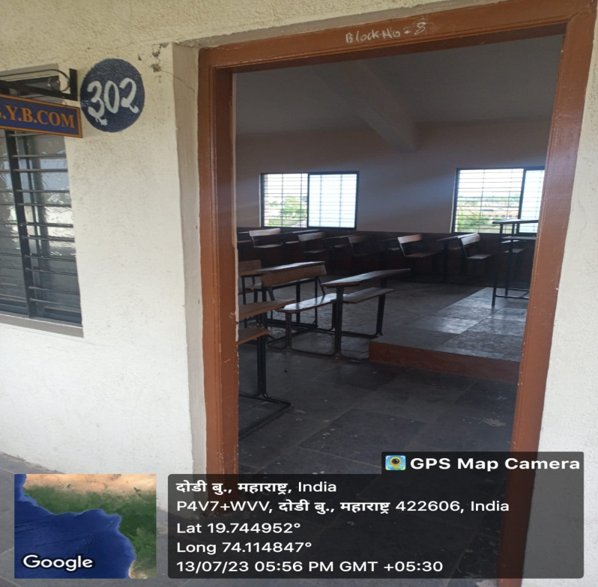

**Room No.303 FYBCOM Class Room**

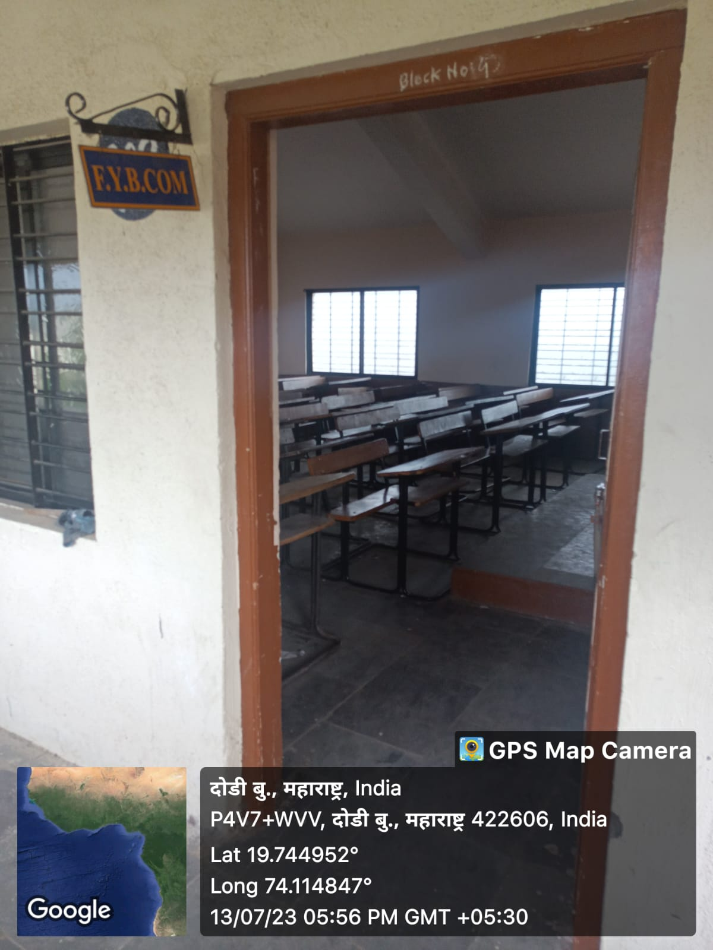

**Room No.304 Seminar Hall**

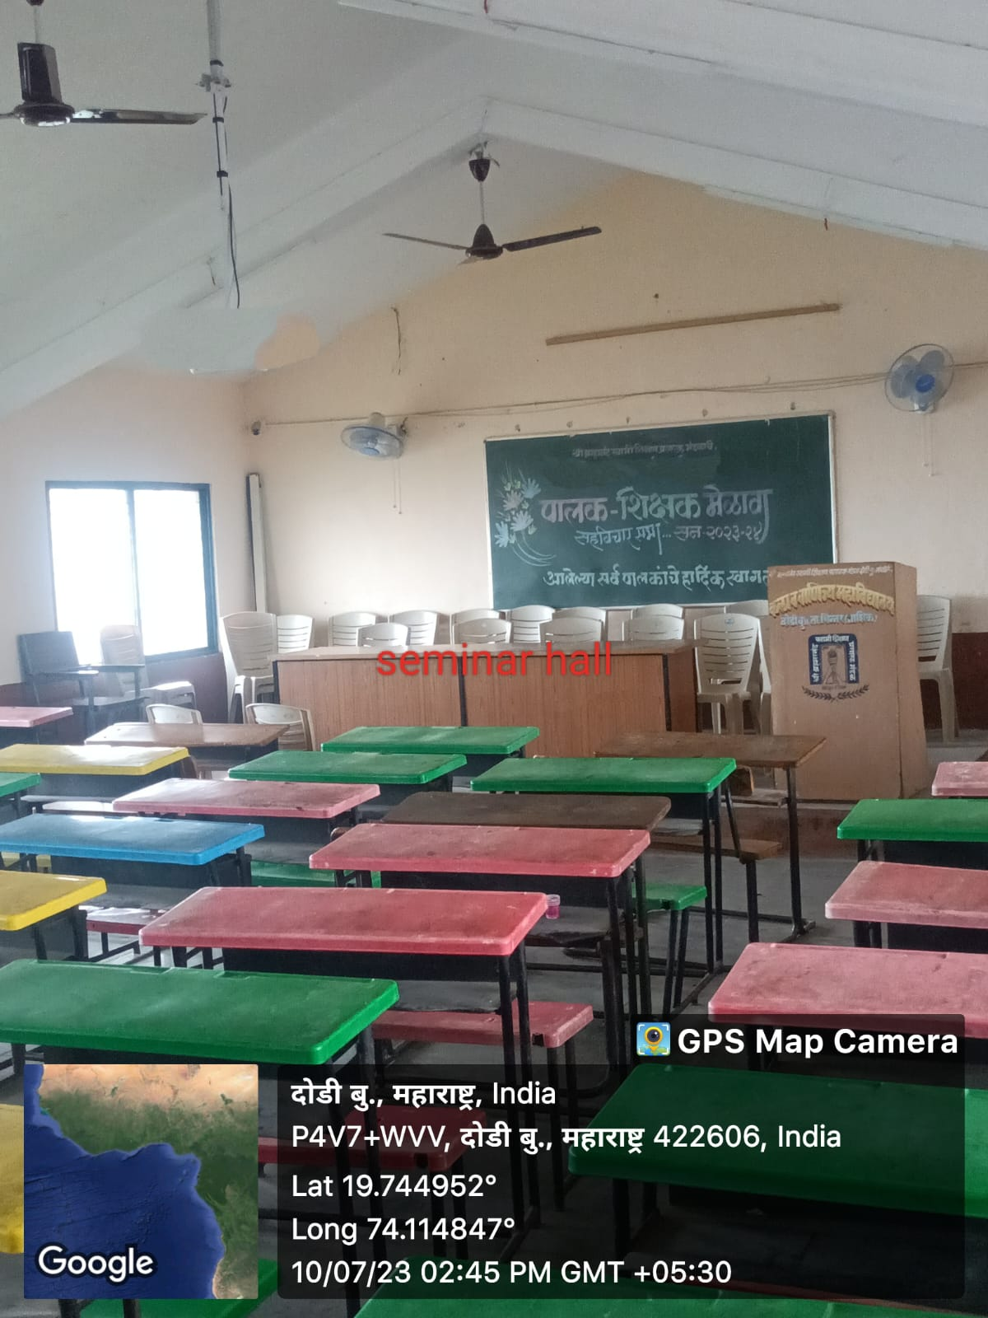

**Play Ground**

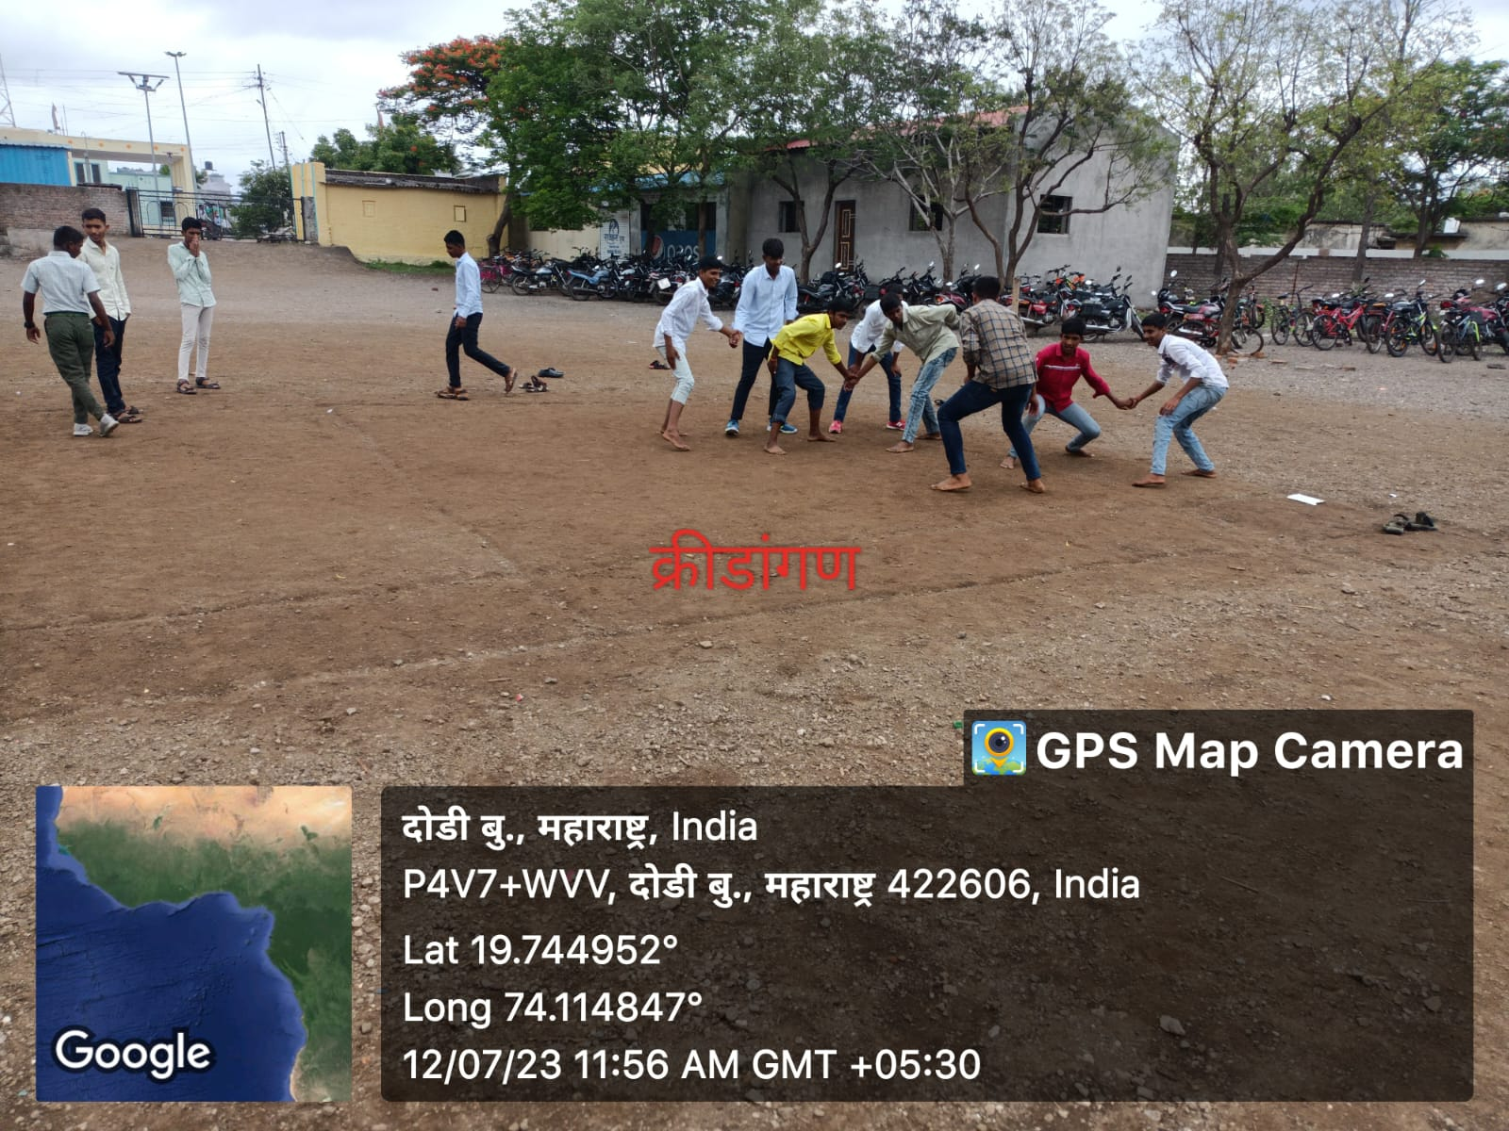

**Toilet**

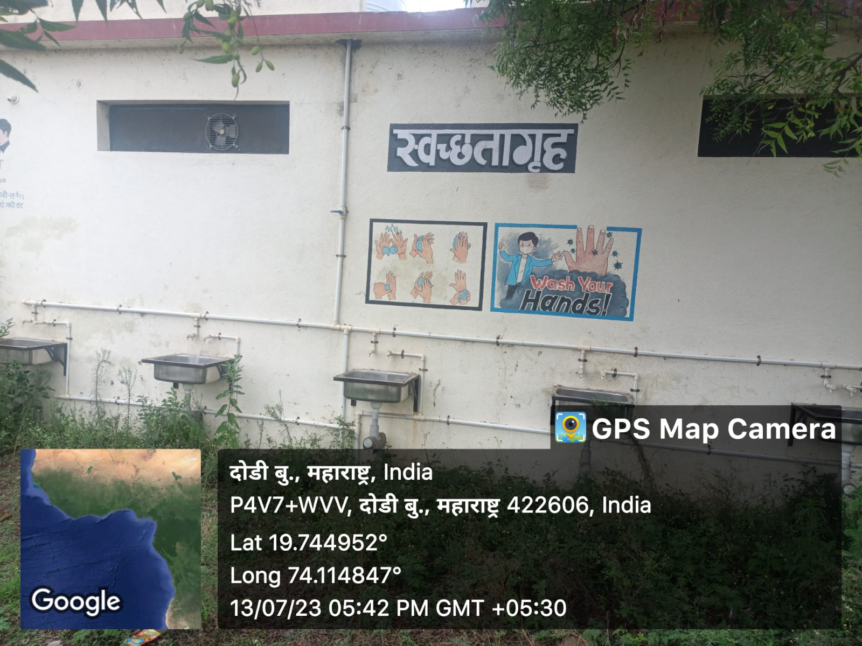

**Toilet Female**

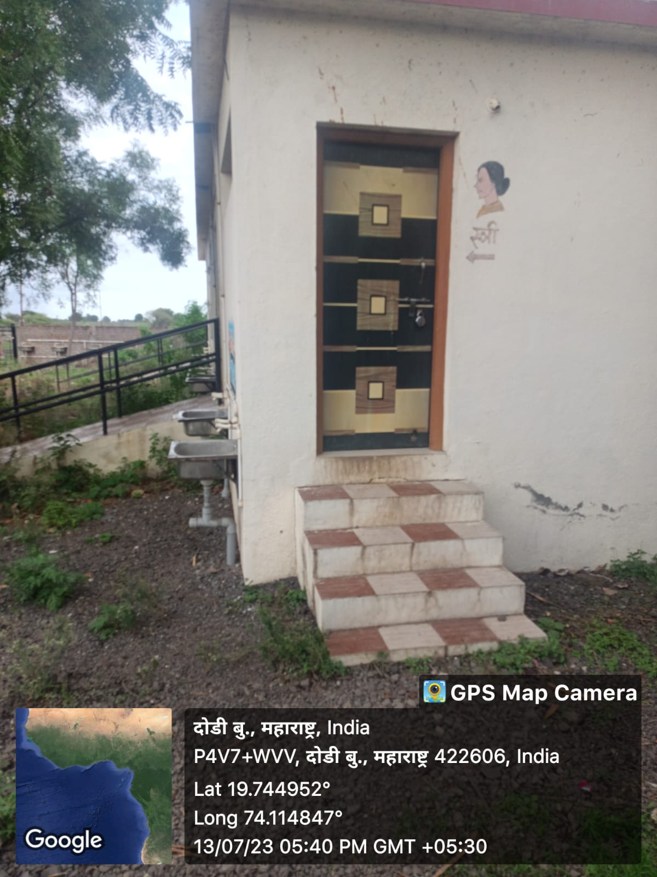

**Toilet male**

